1. Find *.sql files int newstatix\database folder   
   In file Job statix_Users_ExpireUsers.sql update the line  
     
   @owner_login_name=N'ARCADIA\Vitaly.Chupaev',  
     
   in file New Statix site support DDL.sql  
    check/update IIS AppPool user.  
     
   Run in order:

- New Statix site support DDL.sql  
- New Statix site support DML.sql  
- ELMAH.sql  
- Job statix_Users_ExpireUsers.sql

1. When configuring IIS, the Admin site must have a virtual folder Themes, which is a reference to the App_Themes folder of the Statix site:

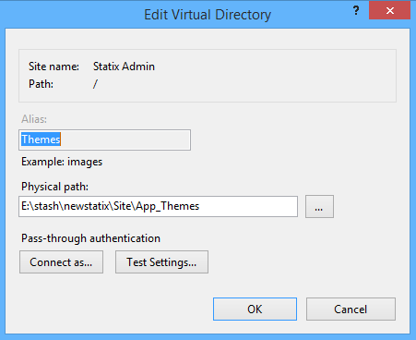

1. Currently the site type (Statix, Newedge, BNP) is determined by host name, it is compared in this way:   
     
   if (Request.Url.ToString().IndexOf("bp2s", StringComparison.OrdinalIgnoreCase) >= 0)  
   {  
    …  
   }  
     
   and   
     
   if (Request.Url.ToString().IndexOf("newedge", StringComparison.OrdinalIgnoreCase) >= 0)  
   {  
    …  
   }
2. Bindings are set in this way:  
     
   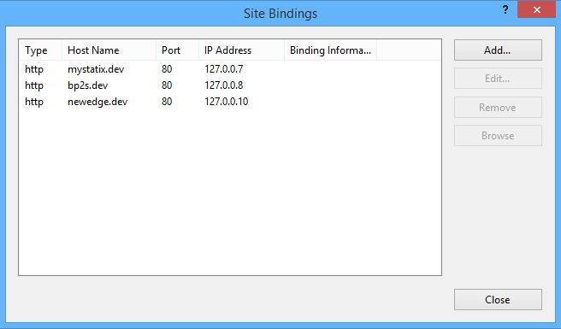
3. If you have problems with Admin UI access (Forbidden), please check in database (IPAddresses table), that your IP address is configured and IsAdminIp flag is set to true.